FOR IMMEDIATE RELEASE
May 30, 2023

POLARIS Laboratories® Increases STLE Leadership Involvement

POLARIS Laboratories® announces two leaders of the company’s Data Analysis team have been inducted into the STLE Board of Directors, the newly founded Diversity, Equity and Inclusion Committee (DEIC) and OMA Committee, respectively.
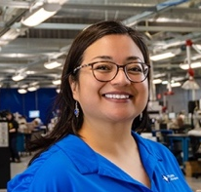
Elaine Hepley, Data Analysis Manager, was inducted into the 2023-2024 STLE Board of Directors during the 77th STLE Annual Meeting and Exhibition held May 21-25, 2023. Elaine has been a member of STLE for 5 years, has held positions as Chair of STLE’s OMA Committee, is paper solicitation chair (PSC) of STLE’s Power Generation Technical Committee and Chair of the Diversity, Equity and Inclusion Committee (DEIC). Elaine holds her CLS and OMA I certifications and is an active member of the STLE Lower Ohio River Valley (LORV) Section.

“Teamwork makes the dream work, there is no life without challenges and there is no success without failure in between. The best investment anyone can make is in themselves,” says Hepley on her recent induction into the STLE Board of Directors.
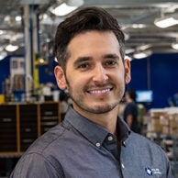
Brandon Van Horn, Data Analysis Supervisor, has been named member of STLE’s OMA Committee and will serve as Vice-Chair. Brandon has held his CLS and OMA I certifications and STLE certifications for 5 years.

With their extensive industry backgrounds and involvement in the STLE organization, Elaine and Brandon understand the significance of STLE’s education efforts for their members. They bring their education, experiences and learnings to both STLE’s members and POLARIS Laboratories® teams, nationally and locally.
####

POLARIS Laboratories® is an independent fluid analysis company headquartered in Indianapolis, Indiana and six additional laboratories around the globe. The company specializes in testing and analyzing oil, coolant, grease and diesel fuel to provide maintenance recommendations that reduce maintenance costs, improve equipment reliability and minimize unscheduled downtime for companies in the transportation, oil and gas, construction, mining and power generation industries. The North American and Poland laboratory locations are ISO17025:2017 accredited by A2LA.
polarislabs.com

